Mashed Potatoes

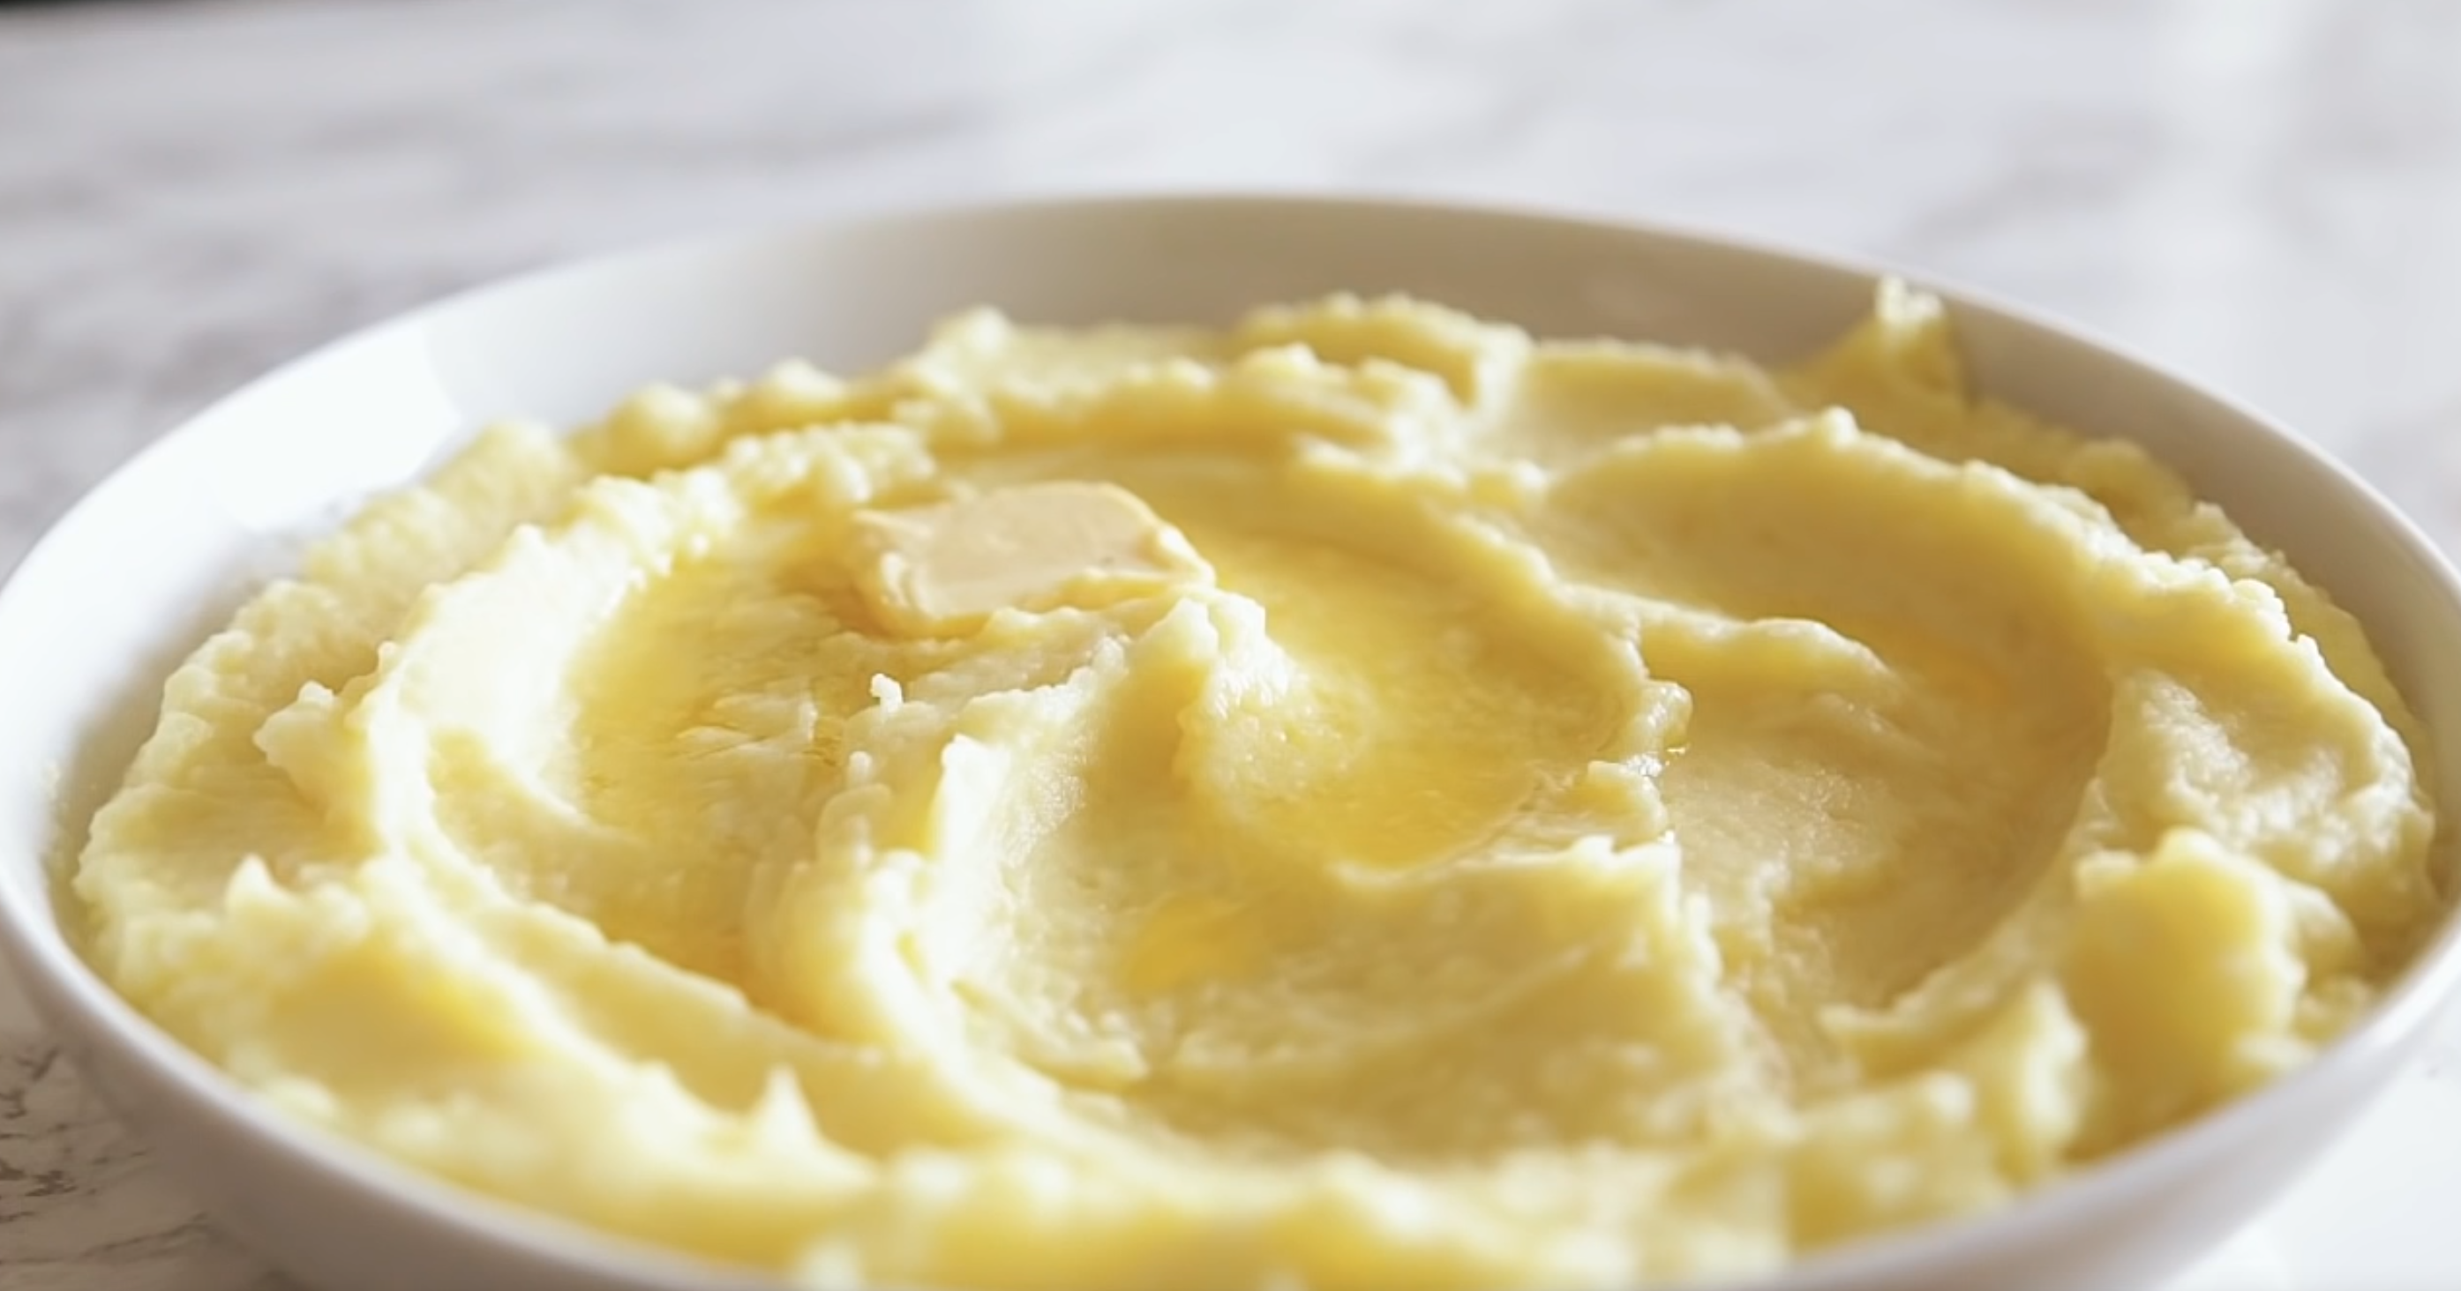

Ingredients you’ll need:

Potatoes

Salt

Butter

Heavy cream

Whole milk

Garlic & herbs (optional)

Instructions:

Peel and cut potatoes into small chunks and add them to a pot of water.

Bring water to boil and cook potatoes until they are fork tender.

Strain potatoes and mash them in preferred way. (fork, ricer, cut with knife, potatoes masher) then add about 4 parts milk, 2 parts butter, 1 part cream until desired flavor and consistency is reached.

For more flavorful mashed potatoes, add the same liquids into a saucepan and warm with crushed garlic and herbs thrown in to infuse the flavors. Once done, strain out any solids and add liquid to the potatoes and continue to mash.